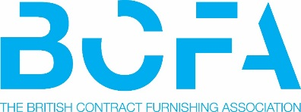

Annual Luncheon Booking Form 2022

The Luncheon will be held at The Royal Lancaster, London on Thursday 3rd^{th} November 2022

Price per ticket £209 + VAT.

Booking Request
Full Name:
Company Name:
Email Address:
Telephone:
Number of tickets you require:
Please advise if you have a preferred member company/companies to share a table with:
Return your completed booking from to Kate Murphy by email kate.murphy@thebcfa.com

Invoices will be issued over the next few days once we have received all bookings and confirmed allocations. Payment must be by return to secure your places, the preferred payment is by BACS. If a PO is required, please include this information on your booking form.

British Contract Furnishing Association
Project House, 25 West Wycombe Road, High Wycombe, Bucks, HP11 2LQ
T: 01494 896790
W:www.thebcfa.com W:www.designinsiderlive.com

